QuickBooks for Windows
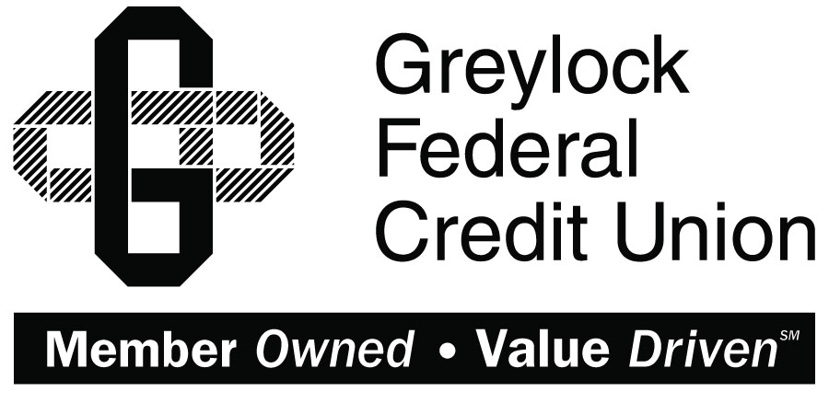

Conversion Instructions
  - QuickBooks for Windows
  - Direct Connect to Web Connect

Introduction
As Greylock Federal Credit Union completes its system conversion you will need to modify your QuickBooks settings to ensure the smooth transition of your data. Please reference the dates next to each task as this information is time sensitive. To complete these instructions, you will need your User ID and Password for the Greylock Federal Credit Union’s online banking.
It is important that you perform the following instructions exactly as described and in the order presented. If you do not, your service may stop functioning properly. This conversion should take 15–30 minutes.
This detour symbol indicates section instructions that are using bill pay within QuickBooks only. If you do not use QuickBooks to make online bill payments, you can skip these sections or steps.

Documentation and Procedures
- Conversion Preparation
- Backup your data file. For instructions to back up your data file, choose Help menu > QuickBooks Help. Search for Back Up and follow the instructions.
- Download the latest QuickBooks update. For instructions to download an update, choose Help menu > QuickBooks Help. Search for Update QuickBooks, then select Update QuickBooks and follow the instructions.
If multiple computers do not use the same QuickBooks data file, skip step 3. QuickBooks activities such as Online Banking cannot be performed in multi-user mode because of the way the activities interact with a company data file.
- Switch to single user mode. For instructions to switch to single user mode, choose Help menu > QuickBooks Help. Search for Switch to Single User Mode and follow the instructions.
If you are not using Classic Mode (Register Mode), enable it for the conversion. You can change it back after the conversion is complete.
- Enable Classic Mode (Register Mode).
- For instructions to enable Classic Mode (Register Mode), choose Help menu > QuickBooks Help. Search for Banking Feed Modes, then select Bank Feed Modes overview, and follow the instructions.
- Cancel Outstanding Payments by 10/18/2017
If you are not a bill pay user within QuickBooks, please skip this section.
This step must be completed by [Conversion Date] to avoid possible duplicate payment. If you do not cancel payments scheduled to be paid after [Conversion Date], then it is possible that these payments will still be processed.
- Open the Register of the account you made the payment from.
- Click Company > Chart of Accounts.
- Double-click the account to use.
- In the register, locate the transaction you want to cancel.
- Click the transaction to select it.
- Go to Edit menu and then click Cancel Payment.
- The cancellation appears in the Items to Send list of the Online Banking Center (Bank Feeds Center). When you send and receive transactions, it is sent to the financial institution.
- Match Downloaded Transactions
If new transactions were received from your connection, accept all new transactions into the appropriate registers.
If you need assistance matching transactions, choose Help menu > QuickBooks Help. Search for Matching Transactions and follow the instructions.
- Deactivate Your Account(s) at Greylock Federal Credit Union on or after 10/18/2017
All transactions must be matched or added to the register prior to deactivating your account(s).
- Choose Lists menu > Chart of Accounts.
- Select the account you want to deactivate.
- Choose Edit menu > Edit Account.
- Click on the Bank Feed Settings tab in the Edit Account window.
- Select Deactivate All Online Services and click Save & Close.
- Click OK for any dialog boxes that may appear with the deactivation.
- Repeat steps 2 – 6 for each account at Greylock Federal Credit Union
- Backup your data file.
- Re-activate Your Account(s) at Greylock FCU on or after 10/18/2017
- Log in to www.greylock.org and download your QuickBooks Web Connect file.
- Click File > Utilities > Import > Web Connect Files.
Take note of the date you last had a successful connection. If you have overlapping dates in the web-connect process, you may end up with duplicate transactions.
- If prompted for connectivity type, select Web Connect.
- Link your bank account with the existing QuickBooks account and click Continue.
- Re-enable Express Mode (if necessary)
If you prefer Classic Mode (Register Mode), you are finished with your conversion. If you use Express Mode for online banking, you may now re-enable the mode.
For instructions to enable Express Mode, choose Help > QuickBooks Help. Search for Banking Feed Modes, then select Bank Feed Modes overview, and follow the instructions.

Thank you for making these important changes!

