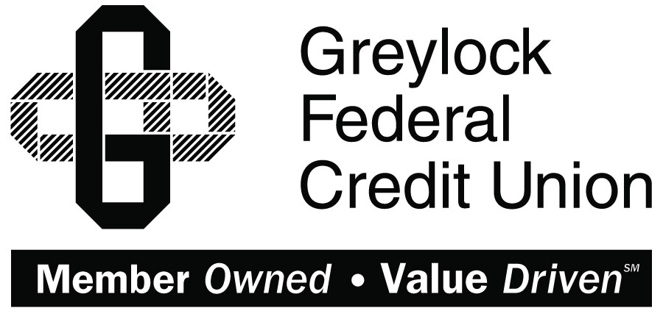

Quicken for Mac 2015-2017

Conversion Instructions
  - Direct Connect to Express Web Connect

Introduction
As Greylock Federal Credit Union completes its system conversion you will need to modify your Quicken settings to ensure the smooth transition of your data. Please reference the dates next to each task as this information is time sensitive.
To complete these instructions, you will need your User ID and Password for each Financial Institution.
Express Web Connect uses the same User ID and Password as Greylock Federal Credit Union’s online banking.
You should perform the following instructions exactly as described and in the order presented. If you do not, your online banking connectivity may stop functioning properly. This conversion should take 15–30 minutes.
Thank you for making these important changes!
This detour symbol indicates instructions in a Task specifically for Bill Pay within Quicken (Not available in Quicken for Mac 2015). If you do not use Quicken to make bill payments, skip that Task.

Documentation and Procedures
- Conversion Preparation
- Backup your data file. For instructions to back up your data file, choose Help menu > Search. Search for Backing Up, select Backing up data files, and follow the instructions.
- Download the latest Quicken Update. For instructions to download an update, choose Help menu > Search. Search for Updates, select “Check for Updates,” and follow the instructions.
- Cancel Outstanding Payments before 10/18/2017 (Not available in Mac 2015)
If you are not a Bill Pay user within Quicken, skip this Task.
This Task must be completed to avoid possible duplicate payment. If you do not cancel payments scheduled to be paid on or after 10/18/2017, these payments may still be processed.
- Highlight a Bill Payment transaction on the account register.
While on the account register, go to File > Print to save your list of pending payments. You can use this when you recreate and send these payments later.
- Click on the Edit button located on the action bar at the bottom of the account register window.
- Click on the Edit Details tab located below the highlighted transaction.
- Click on the Online Payment tab.
- Click on Cancel Payment.
- Repeat steps for each outstanding payment transaction you have with your financial institution.
- Disconnect Accounts At Greylock Federal Credit Union on or after 10/18/2017
- Select your account under the Accounts list on the left side.
- Choose Accounts menu > Settings.
- Select Troubleshooting > Deactivate Downloads.
- Repeat steps for each account to be disconnected.
- Reconnect Accounts to Greylock FCU on or after 10/25/2017
- Select your account under the Accounts list on the left side.
- Choose Accounts menu > Settings.
- Select Set up transaction download.
- Enter Greylock FCU in the Search field, select the name in the Results list and click Continue.
- Enter your User Id and Password and click Continue.
- If the bank requires extra information, enter it to continue.
Select “Express Web Connect” or “Quicken Connect” for the “Connection Type” if prompted.
- In the “Accounts Found” screen, ensure you associate each new account to the appropriate account already listed in Quicken. Under the Action column, select “Link” to pick your existing account.
Do NOT select “ADD” under the action column.
- Select Finish.

