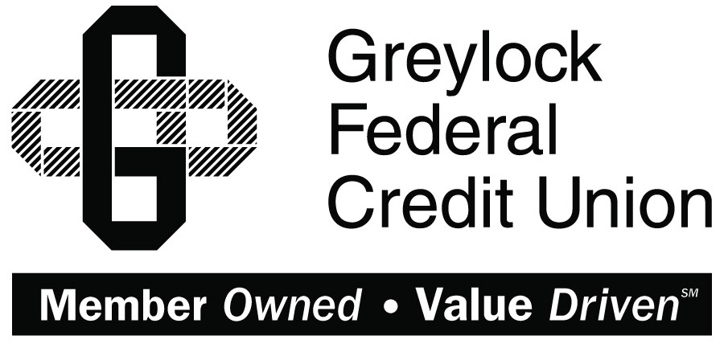

Quicken for Mac 2007

Conversion Instructions
  - Direct Connect to Web Connect

Introduction
As Greylock Federal Credit Union completes its system conversion, you will need to modify your Quicken settings to ensure the smooth transition of your data. Please reference the dates next to each task as this information is time sensitive.
To complete these instructions, you will need your User ID and Password for each Financial Institution.
Web Connect uses the same User ID and Password as the Greylock Federal Credit Union online banking.
You should perform the following instructions exactly as described and in the order presented. If you do not, your online banking connectivity may stop functioning properly. This conversion should take 15–30 minutes.
Thank you for making these important changes!
This detour symbol indicates instructions in a Task specifically for Bill Pay within Quicken. If you do not use Quicken to make online bill payments, skip that Task.

Documentation and Procedures
- Conversion Preparation
- Backup your data file. For instructions to back up your data file, choose Help menu > Search. Search for Backing Up, select “Backing up data files,” and follow the instructions.
- Download the latest Quicken Update. For instructions to download an update, choose Help menu > Search. Search for Updates, select “Check for Updates,” and follow the instructions.
- Cancel Outstanding Payments before 10/18/2017
If you are not a Bill Pay user within Quicken, skip this Task.
This Task must be completed to avoid possible duplicate payment. If you do not cancel payments scheduled to be paid on or after 10/18/2017, these payments may still be processed.
- In your account register, check the Number column to see if there are any online payments scheduled for delivery after 10/18/2017
- Choose File menu > Print Register to save a copy of your list of pending payments. Specify the transaction date range to print and click OK. You may select to save this as a PDF or send to your printer.
You will use this list later to recreate your payments.
- Click to select the first pending transaction in your account register. Choose Online menu > Payments > Cancel Payment. Quicken determines if there is enough time to cancel the payment:
- If there is not enough time to cancel, then it should process correctly in your current account. Repeat this step with a different pending transaction.
- If there is enough time to cancel, then click Put In Outbox in the Cancel Payment dialog.
- Repeat step 3 for each additional pending transaction.
- Choose Online menu > Payments > Send Payment. Ensure all payment cancellations have a checkmark in the Send column.
- Click Send Now.
- In the Online Transmission Summary, verify that your payments were successfully cancelled.
- Click OK to close the Online Transmission Summary.
- Repeat steps for each account to be deactivated that is enabled for bill payment services.
- Disconnect Accounts At Greylock Federal Credit Union on or after 10/18/2017
- Choose Lists menu > Accounts.
- Select the account that you want to disable and click Edit.
- Write down your account information (account number, routing number, and customer ID).
You will need this information to re-enable your account.
- If you use online payment services, then select Not Enabled in the Pay Bills Online drop-down list. Follow the prompts to confirm the deactivation.
- In the Download Transactions drop-down list, select Not Enabled. Follow the prompts to confirm the deactivation.
- Remove the information within the Account Number and Routing Number fields.
- Click OK to save your edits.
- Repeat steps for each account to be disconnected.
- Verify that your account list does not display a blue online circle icon for any accounts at Greylock Federal Credit Union.
- Reconnect Accounts to Greylock FCU on or after 10/18/2017
- Download your Quicken Web Connect file from www.greylock.org
Take note of the date you last had a successful connection. If you have overlapping dates in the web-connect process, you may end up with duplicate transactions.
- Import your transactions to Quicken.
- Associate the account to the appropriate account already listed in Quicken. Select Use an existing account.
- Match the transactions you are importing to the corresponding existing Quicken account in the drop-down list and click OK.
- Repeat steps for each account to be reconnected.
- Choose Lists menu > Accounts. Verify each account at Greylock FCU has a blue online circle indicating it has been reconnected for online services.

